LAB # 09

Task No 01: Write a program and create the objects of classes in class car to explain the concept of composition. Create several classes as engine, doors, capacity, and wheel having their individual methods attributes. The object of these classes is created in a car class, and they are set as public. The object of this car class is created in Main method and this with the help of this object we can call other classes as well and can use their functionalities and design UML class diagram.

Code:

Main:

package lab09task01;

public class Lab09task01 {

    public static void main(String[] args) {

        Car c1 = new Car();

        c1.startCar();

        c1.openDoors();

        c1.printCapacity();

        c1.rotateWheels();

        c1.closeDoors();

        c1.stopCar();

    }

}

Car:

package lab09task01;

public class Car {

    public Engine engine;

    public Door door;

    public Capacity capacity;

    public Wheel wheel;

    public Car() {

        engine = new Engine();

        door = new Door(5);

        capacity = new Capacity(5);

        wheel = new Wheel(6);

    }

    public void startCar() {

        engine.start();

    }

    public void stopCar() {

        engine.stop();

    }

    public void openDoors() {

        door.open();

    }

    public void closeDoors() {

        door.close();

    }

    public void printCapacity() {

        System.out.println("Seating capacity : " + capacity.getCapacity());

    }

    public void rotateWheels() {

        wheel.rotate();

    }

}

Engine:

package lab09task01;

public class Engine {

    public void start() {

        System.out.println("Engine is Started");

    }

    public void stop() {

        System.out.println("Engine has Stopped");

    }

}

Wheel:

package lab09task01;

public class Wheel {

    private int wheel;

    public Wheel(int wheel) {

        this.wheel = wheel;

    }

    public int getWheel() {

        return wheel;

    }

    public void rotate() {

        System.out.println("Wheel is Rotating");

    }

}

Door:

package lab09task01;

public class Door {

    private int no_doors;

    public Door(int no_doors) {

        this.no_doors = no_doors;

    }

    public int getNo_doors() {

        return no_doors;

    }

    public void open() {

        System.out.println("Doors is Open");

    }

    public void close() {

        System.out.println("Doors is Close");

    }

}

Capacity:

package lab09task01;

public class Capacity {

    private int capacity;

    public Capacity(int capacity) {

        this.capacity = capacity;

    }

    public int getCapacity() {

        return capacity;

    }

}

Output:

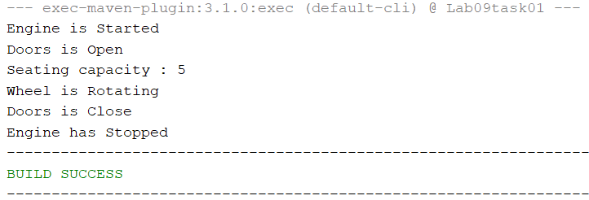

UML Diagram:

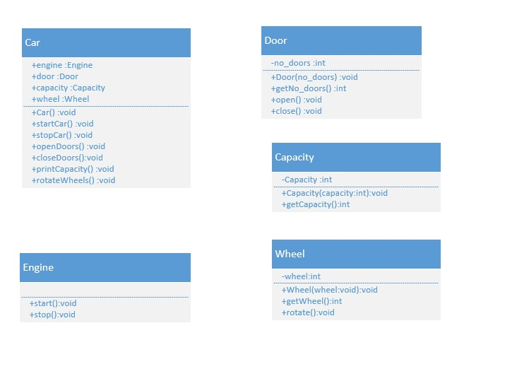

Task No 02: Write complete program for Flight's class, Time's class, and Passenger's class with the concept of association and aggregation and design UML class diagram. Functions information also been given in the table below:

|  |  |
| --- | --- |
| **Method** | **Description** |
| addPassenger(Passenger) | This method will add Passenger's object to vector passengerList. |
| printInfo() | This method will display all flight information namely ID (Flight number), destination, departure time, arrival time and number of passengers.  For Example:  Flight no: PK-303  Destination: Lahore  Departure: 8:10  Arrival: 9:00  Number of passengers :2 |
| getHour() | This method will return the value of attribute **hour** |
| getMinute() | This method will return the value of attribute **minute** |

Code:

Main:

package lab09task02;

public class Lab09task02 {

    public static void main(String[] args) {

        Passenger p1 = new Passenger("Omair", 20);

        Passenger p2 = new Passenger("Ali", 30);

        Passenger p3 = new Passenger("Usman", 10);

        Passenger p4 = new Passenger("Umer", 25);

        Passenger p5 = new Passenger("Muhammad", 29);

        Flight f1 = new Flight("PK-204", "London", new Time(2, 19), new Time(4, 35));

        f1.addPassenger(p1);

        f1.addPassenger(p2);

        f1.addPassenger(p3);

        f1.addPassenger(p4);

        f1.addPassenger(p5);

        f1.printInfo();

    }

}

Flight:

package lab09task02;

import java.util.*;

public class Flight {

    String flight_no;

    String destination;

    Time departuretime;

    Time arrivaltime;

    private List<Passenger> passengerList = new ArrayList<Passenger>();

    Flight(String flight_no, String destination, Time departuretime, Time arrivaltime) {

        this.flight_no = flight_no;

        this.destination = destination;

        this.departuretime = departuretime;

        this.arrivaltime = arrivaltime;

    }

    public void addPassenger(Passenger p) {

        this.passengerList.add(p);

    }

    public void printInfo() {

        System.out.println("Flight : " + flight_no);

        System.out.println("Destination : " + destination);

        System.out.println("Departure : " + timeconvert(departuretime));

        System.out.println("Arrival : " + timeconvert(arrivaltime));

        System.out.println("Number of passengers : " + passengerList.size());

    }

    public String timeconvert(Time t) {

        return String.format("%d:%d", t.hours, t.minute);

    }

}

Time:

package lab09task02;

public class Time {

    int hours;

    int minute;

    public Time() {

    }

    Time(int hours, int minute) {

        this.hours = hours;

        this.minute = minute;

    }

    public int getHours() {

        return hours;

    }

    public int getMinute() {

        return minute;

    }

}

Passenger:

package lab09task02;

public class Passenger {

    String name;

    int age;

    Passenger(String name, int age) {

        this.name = name;

        this.age = age;

    }

}

Output:

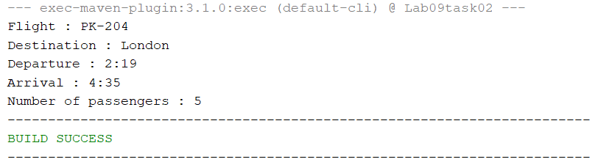

UML Diagram:

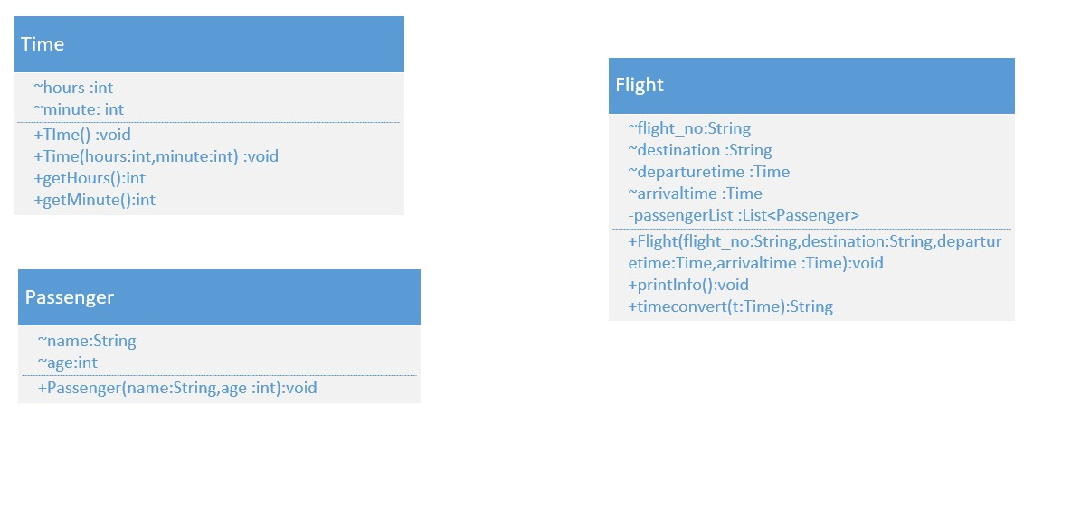

Task No 03: A company manages many stores. Each Store contains many Products. Implement Product, Store and Company classes using association and aggregation concepts and design UML class diagram.

Code:

Main:

package lab09task03;

import java.util.*;

public class Lab09task03 {

    public static void main(String[] args) {

        Product p1 = new Product("Rice", 200, 80);

        Product p2 = new Product("Sugar", 900, 90);

        Product p3 = new Product("Shampoo", 800, 50);

        Product p4 = new Product("Bread", 500, 40);

        Product p5 = new Product("Soap", 500, 10);

        Product p6 = new Product("Butter", 1000, 30);

        List<Product> branch1_product = new ArrayList<Product>();

        List<Product> branch2_product = new ArrayList<Product>();

        branch1_product.add(p1);

        branch1_product.add(p2);

        branch1_product.add(p5);

        branch2_product.add(p4);

        branch2_product.add(p3);

        branch2_product.add(p6);

        Store store1 = new Store("Karachi Branch", branch1_product);

        Store store2 = new Store("Punjab Branch", branch2_product);

        List<Store> Store = new ArrayList<Store>();

        Store.add(store1);

        Store.add(store2);

        Company C1 = new Company("ABC", Store);

        C1.showallitems();

    }

}

Company:

package lab09task03;

import java.util.*;

public class Company {

    String name;

    private List<Store> store;

    public Company(String name, List<Store> store) {

        this.name = name;

        this.store = store;

    }

    public void showallitems() {

        List<Product> product;

        for (Store s : store) {

            System.out.println("\n" + s.name);

            product = s.getProducts();

            for (Product p : product) {

                System.out.println(p.name);

            }

        }

    }

}

Store:

package lab09task03;

import java.util.*;

public class Store {

    String name;

    private List<Product> products;

    public Store(String name, List<Product> products) {

        this.name = name;

        this.products = products;

    }

    public List<Product> getProducts() {

        return products;

    }

}

Class:

package lab09task03;

public class Product {

    String name;

    int price;

    int quantity;

    Product(String name, int price, int quantity) {

        this.name = name;

        this.price = price;

        this.quantity = quantity;

    }

}

Output:

UML Diagram:

